**EXPERIMENT NO. 1**

**Aim : To study different laws and standards of cyber security**

# Theory :

Cybersecurity refers to the practice of defending systems, networks, and programs from digital attacks, which can lead to data breaches, theft of intellectual property, or damage to a company’s reputation.

 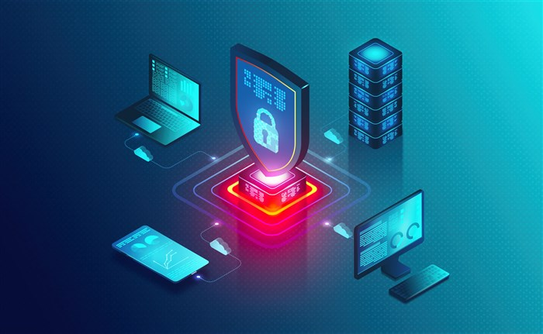

**Key Objectives of Cybersecurity:**

* **Confidentiality**: Ensuring that sensitive information is accessible only to those who are authorized to access it.
* **Integrity**: Ensuring that data is accurate, complete, and unaltered unless authorized.
* **Availability**: Ensuring that systems and data are available when needed, without disruption or denial of service.

### 2. ****Types of Cyber Attacks****

Cyberattacks are categorized into two primary types:

#### ****A. Web-based Attacks****

Web-based attacks primarily target online platforms, websites, and web applications. These attacks often exploit vulnerabilities in the web infrastructure to compromise or steal data. Below are some of the most common and dangerous web-based attacks:

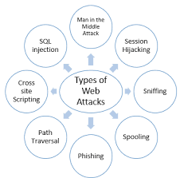

1. **Phishing**
   * **Description**: Phishing is a form of **social engineering**, where attackers send fraudulent emails, messages, or pop-up alerts that appear to be from legitimate sources (such as banks, government agencies, or popular websites). The goal is to trick the victim into providing sensitive data like usernames, passwords, or credit card details.
   * **Example**: An attacker might send an email pretending to be from a bank, asking the recipient to click on a link that leads to a fake login page where their credentials are harvested.
   * **Prevention**:
     + Use **email filtering** systems to detect suspicious messages.
     + Educate users on **spotting phishing emails** (look for spelling errors, generic greetings, and strange links).
     + Employ **multi-factor authentication (MFA)** to add an extra layer of security.
2. **SQL Injection**
   * **Description**: SQL injection is an attack where malicious SQL queries are injected into an input field, like a login form or search bar, in a web application. These queries can be executed by the backend database, allowing attackers to view, alter, or delete data, and in some cases, execute administrative operations on the database.
   * **Example**: An attacker may input OR 1=1 into a login form, potentially allowing them to bypass authentication and access the system.
   * **Prevention**:
     + **Parameterize queries** instead of directly inserting user input into SQL statements.
     + Use **stored procedures** and ensure proper validation and sanitization of all user inputs.
     + Implement **web application firewalls (WAF)** to block malicious requests.
3. **Cross-Site Scripting (XSS)**
   * **Description**: XSS involves injecting malicious scripts (typically JavaScript) into web pages viewed by other users. These scripts are executed by users' browsers and can steal session cookies, login credentials, or redirect users to malicious websites.
   * **Example**: An attacker might inject a script into a comment section of a website. When another user views the comment, the script runs in their browser and steals their session cookie.
   * **Prevention**:
     + **Sanitize and validate** all user-generated content, especially content like HTML forms, comments, and URL parameters.
     + Use **Content Security Policy (CSP)** to restrict the sources of executable scripts.
     + Implement **HTTP-only cookies** to prevent cookies from being accessed via JavaScript.
4. **Denial of Service (DoS) and Distributed Denial of Service (DDoS)**
   * **Description**: DoS attacks aim to overwhelm a website, server, or network with traffic, rendering it unavailable to legitimate users. In a DDoS attack, the traffic is generated from multiple compromised systems (often forming a **botnet**), making it harder to block.
   * **Example**: A botnet sends massive amounts of traffic to a target website, causing the server to crash or become too slow for legitimate users to access.
   * **Prevention**:
     + Use **Content Delivery Networks (CDNs)** and **load balancers** to distribute traffic and absorb large spikes.
     + Implement **rate limiting** and **firewalls** to detect and block malicious traffic.
     + Use **DDoS mitigation services** like Cloudflare, Akamai, or AWS Shield.

#### ****B. System-based Attacks****

System-based attacks typically focus on compromising the integrity or security of a computer system, operating system, or network infrastructure. These attacks exploit vulnerabilities in software or hardware to gain unauthorized access or disrupt services.

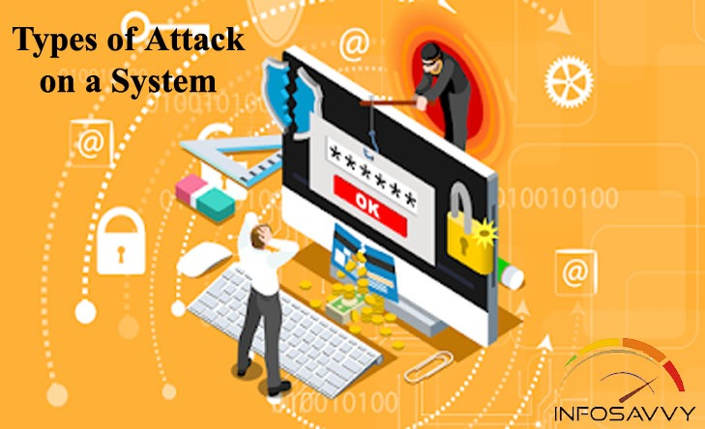

1. **Malware (Malicious Software)**
   * **Description**: Malware is a broad term for any software designed to harm or exploit a system. Types of malware include **viruses**, **worms**, **trojans**, **ransomware**, **spyware**, and **adware**. It can steal, encrypt, or delete sensitive data, damage system functionality, or monitor user activity.
   * **Example**: A ransomware attack encrypts a user’s files, demanding a ransom payment in exchange for the decryption key.
   * **Prevention**:
     + Use **antivirus software** and regularly update it.
     + Implement **firewalls** and **endpoint protection** to block malicious network traffic.
     + Encourage users to avoid downloading files or clicking on suspicious links.
2. **Man-in-the-Middle (MITM) Attack**
   * **Description**: MITM attacks involve an attacker intercepting communication between two parties (such as between a user and a website) and potentially altering the data. This can lead to **eavesdropping** (stealing data), **data manipulation**, or impersonating one of the parties.
   * **Example**: An attacker intercepts a login request to a website over an unsecured connection (like HTTP), captures the login credentials, and then uses them to access the account.
   * **Prevention**:
     + Use **SSL/TLS encryption** (HTTPS) to secure communication.
     + Implement **public key infrastructure (PKI)** to ensure the authenticity of communications.
     + Use **VPNs** to secure data transmissions over untrusted networks.
3. **Privilege Escalation**
   * **Description**: This occurs when an attacker gains elevated privileges on a system, typically by exploiting vulnerabilities to gain administrator or root-level access. Once this higher level of access is obtained, the attacker can perform actions that are typically restricted.
   * **Example**: An attacker might exploit a vulnerability in the OS or an application to gain root privileges, allowing them to install malicious software or access restricted files.
   * **Prevention**:
     + Implement the principle of **least privilege**, ensuring that users and applications only have the minimum necessary permissions.
     + Regularly **patch and update** software to fix known vulnerabilities.
     + Use **multi-factor authentication (MFA)** for administrative access.
4. **Rootkits**
   * **Description**: Rootkits are a type of malicious software designed to give an attacker persistent, undetected access to a computer system. They typically hide their presence by altering system files or using advanced techniques to avoid detection by antivirus programs.
   * **Example**: A rootkit might allow an attacker to access and control a system remotely without the user's knowledge, while simultaneously masking its presence.
   * **Prevention**:
     + Regularly scan systems with specialized **rootkit detection tools**.
     + Use **security monitoring** tools to detect unusual system behavior or unauthorized access.
     + Implement **regular backups** to recover from compromised systems.
5. **Zero-Day Exploits**
   * **Description**: A zero-day exploit takes advantage of a previously unknown vulnerability in software or hardware. The term "zero-day" refers to the fact that the vendor has "zero days" to patch the vulnerability before it can be exploited by attackers.
   * **Example**: An attacker finds a flaw in a popular web browser that allows them to execute code on the victim’s machine. The attack happens before the vendor releases a patch.
   * **Prevention**:
     + Implement a **rigorous patch management** strategy to apply updates as soon as they are available.
     + Monitor **threat intelligence feeds** for information about newly discovered vulnerabilities and exploits. 
     + Use **intrusion detection systems (IDS)** to identify unusual system behavior that could indicate an exploit.

### 3. ****Different Laws of Cybersecurity****

Cybersecurity laws vary by country, but several international and regional frameworks are commonly applied to govern the legal aspects of cybersecurity. These laws often deal with data protection, cybercrime, and critical infrastructure protection.

#### A. ****International Cybersecurity Laws and Frameworks****

* **General Data Protection Regulation (GDPR)**: A regulation by the European Union that focuses on data protection and privacy for all individuals within the EU and the European Economic Area (EEA).
* **Convention on Cybercrime (Budapest Convention)**: The first international treaty aimed at addressing cybercrime by harmonizing national laws, improving investigative techniques, and increasing cooperation among nations.
* **The NIST Cybersecurity Framework**: A voluntary framework developed by the National Institute of Standards and Technology (NIST) to help organizations identify, assess, and manage cybersecurity risks.

#### B. ****Cybersecurity Laws in the United States****

* **Computer Fraud and Abuse Act (CFAA)**: A law that criminalizes unauthorized access to computers, data breaches, and cybercrimes in the U.S.
* **Health Insurance Portability and Accountability Act (HIPAA)**: A law that sets standards for the protection of health information in the U.S., which includes cybersecurity aspects for healthcare organizations.
* **California Consumer Privacy Act (CCPA)**: A state law that regulates how businesses collect and manage consumer data, with an emphasis on consumer privacy rights.

#### C. ****Cybersecurity Laws in Other Countries****

* **China's Cybersecurity Law**: Regulates cybersecurity practices and imposes strict rules on data privacy, particularly for foreign companies operating in China.
* **India's Information Technology Act (IT Act)**: Governs cybercrime and electronic commerce in India, including provisions for data protection and penalties for cyber offenses.

### 4. ****Standard Cybersecurity Practices****

Cybersecurity standards are frameworks and best practices that provide guidelines for securing systems and data. These standards help organizations implement robust cybersecurity policies and practices.

#### A. ****Common Cybersecurity Standards****

* **ISO/IEC 27001**: An international standard for information security management systems (ISMS), which helps organizations ensure that they implement effective controls to protect sensitive information.
* **NIST Cybersecurity Framework (CSF)**: A set of standards, guidelines, and best practices to manage cybersecurity-related risks. It provides a structured approach to identify, protect, detect, respond, and recover from cyber incidents.
* **SOC 2 (System and Organization Controls 2)**: A framework for managing and securing sensitive data within a service organization, focusing on trust principles like security, availability, confidentiality, and privacy.
* **PCI-DSS (Payment Card Industry Data Security Standard)**: A set of standards designed to ensure that all companies handling credit card information maintain secure systems and networks.

#### B. ****Key Security Controls****

Cybersecurity standards often focus on implementing specific security controls, such as:

* **Access Control**: Limiting access to systems and data based on roles and permissions.
* **Encryption**: Using cryptography to protect data both in transit and at rest.
* **Network Security**: Implementing firewalls, intrusion detection/prevention systems (IDS/IPS), and secure communication protocols (e.g., SSL/TLS).
* **Incident Response**: Establishing procedures for detecting, responding to, and recovering from security incidents, including data breaches and cyberattacks.

#### C. ****Cybersecurity Best Practices****

Organizations are encouraged to adopt best practices, such as:

* **Regular Security Audits**: Continuously assessing the security posture of systems and networks.
* **User Education and Training**: Ensuring that employees understand the importance of security and are aware of threats like phishing and malware.
* **Patch Management**: Keeping software and systems up to date with the latest security patches to mitigate vulnerabilities.
* **Backup and Disaster Recovery**: Ensuring that critical data is regularly backed up and can be recovered in case of an attack, such as ransomware.

### Conclusion

Understanding cybersecurity laws and standards is essential for both organizations and individuals to protect against cyber threats. The landscape of cyber threats is constantly evolving, and so are the laws and regulations that govern cybersecurity. By staying informed about the latest standards and legal requirements, organizations can better safeguard their data, systems, and reputation.

